**DAILY ONLINE ACTIVITIES SUMMARY**

|  |  |  |  |  |  |  |  |  |
| --- | --- | --- | --- | --- | --- | --- | --- | --- |
| **Date:** | **27/05/202** | | | | | **Name:** | **Anjali Manohar Prabhu** | |
| **Sem & Sec** | **4th Sem Section - ‘A’** | | | | | **USN:** | **4AL18CS007** | |
| **Online Test Summary** | | | | | | | | |
| **Subject** | | **Object Oriented Concept** | | | | | | |
| **Max. Marks** | | **30** | | **Score** | | | **27** | |
| **Certification Course Summary** | | | | | | | | |
| **Course** | **Pandas- Combining Dataframe 4** | | | | | | | |
| **Certificate Provider** | | | 1. **Great Learning Academy** | | **Duration** | | | **2.5hrs** |
| **Coding Challenges** | | | | | | | | |
| **Problem Statement: 1. Given an array A of size N where the array elements contain values from 1 to N with duplicates, the task is to find the total number of subarrays which starts and ends with the same elements** | | | | | | | | |
| **Status: Completed** | | | | | | | | |
| **Uploaded the report in Github** | | | | | **YES** | | | |
| **If yes Repository name** | | | | | [**https://github.com/vinisharen/lockdown-coding**](https://github.com/vinisharen/lockdown-coding) | | | |
| **Uploaded the report in slack** | | | | | **NO** | | | |

Online Test Details: OOC online test was conducted on date 27/05/2020 from 9:15 to 10:00 on “Module 5”. There were 30 question in total where each question consist of 1 mark, and the score I got is 27/30

Certification Course Details: **Pandas DataFrame** is two-dimensional size-mutable, potentially heterogeneous tabular data structure with labeled axes (rows and columns). A Data frame is a two-dimensional data structure, i.e., data is aligned in a tabular fashion in rows and columns. Pandas DataFrame consists of three principal components, the **data**, **rows**, and **columns**.

Snapshot: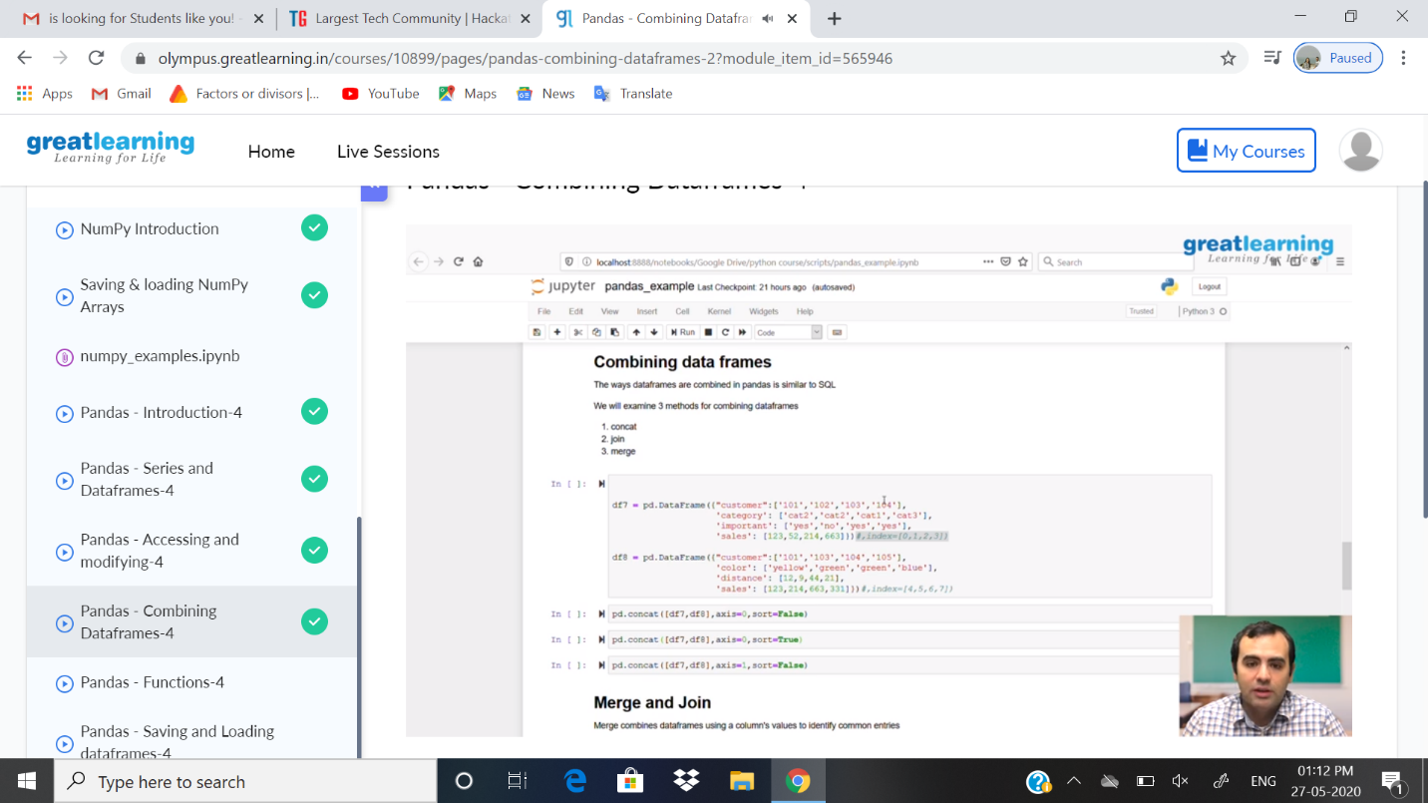

ONLINE CODING DETAILS:

PROBLEM 1: **Given an array A of size N where the array elements contain values from 1 to N with duplicates, the task is to find the total number of subarrays which starts and ends with the same elements**

SNAPSHOT: